TABLE CREATION AND VALUE CREATION

1)QUERY =CREATE TABLE Instructor_71(instructor_ID int Primary Key, Name varchar(30) NOT NULL, D_partment varchar(30));

2) CREATE TABLE Course (course_id INT PRIMARY KEY, Title VARCHAR(30) NOT NULL,Credit INT CHECK (Credit > 0),Instructor_ID INT,FOREIGN KEY (Instructor_ID) REFERENCES Instructor_71(Instructor_ID));

3) CREATE TABLE Student_71(Roll_no int Primary key,Name varchar(30), DOB int ,DEPT varchar(30));

4) CREATE TABLE Enrollment_71(Roll_NO int ,Course_id int,Grade char(2),Primary key (Roll_no,Course_id),foreign key(Roll_no)references Student_71(Roll_no)ON DELETE CASCADE, FOREIGN KEY(Course_id)references Course_71(Course_id)ON DELETE CASCADE);

5) ALTER TABLE Student_71 ADD(Email varchar(20));

1) INSTRUCTOR_71
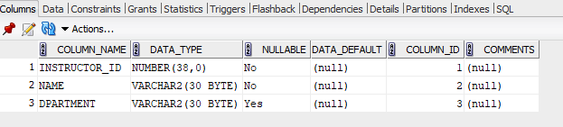

2)COURSE_71

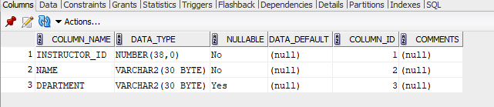

3)Student_71

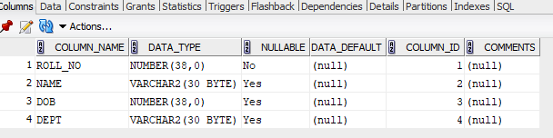
4)

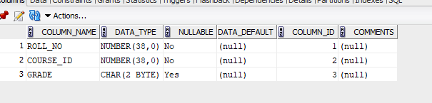

5)

